* Multilevel mixted model analysis

#Using R version 4.1.0 – checking the distribution of antimicrobial consumption rates (DID)

####data of Ireland – rates to 87 months, from January 2015 to March 2022, as a total seven years and three months

Data_rate_year_Ierland <- read_csv("Working rates/Data_rate_year_Ierland.csv")

par(mar=c(1, 1, 1, 1))

descdist(Data_rate_year_Ierland$Rate, discrete = FALSE)

summary statistics

------

min: 11.76764 max: 30.55004

median: 19.9968

mean: 19.94805

estimated sd: 4.008682

estimated skewness: 0.1332716

estimated kurtosis: 2.691972

#The kurtosis and squared skewness of this sample is plottet as a blue point named "Observation". It seems that distributions include the normal

ggqqplot(Data_rate_year_Ierland$Rate)

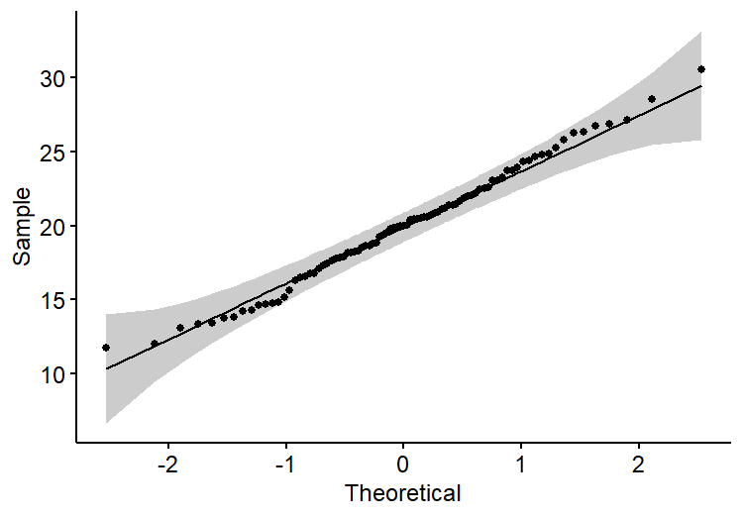

####data of counties – rates to 87 months, from January 2015 to March 2022, as a total seven years and three months

load("Working rates/Data_Rate_total.RData")

table(Data$COUNTY)

Carlow Cavan Clare Cork Cork City

87 87 87 87 87

Donegal Dublin_City Dublin_Dun Dublin_Fin Dublin_South

87 87 87 87 87

Galway Galway City Kerry Kildare Kilkenny

87 87 87 87 87

Laois Leitrim Limerick Limerick City Longford

87 87 87 87 87

Louth Mayo Meath Monaghan Offaly

87 87 87 87 87

Roscommon Sligo Tipperary North Tipperary South Waterford

87 87 87 87 87

Westmeath Wexford Wicklow

87 87 87

# Calculate descdist for each category

descdist_results <- lapply(unique(Data$COUNTY), function(category) {

+ category_data <- Data[Data$COUNTY == category, ]

+ descdist(category_data$Rate, discrete = FALSE)

+ })

descdist_results

[[1]]

summary statistics

------

min: 14.77758 max: 40.21202

median: 23.91534

mean: 24.55545

estimated sd: 5.195949

estimated skewness: 0.3149331

estimated kurtosis: 2.871438

[[2]]

summary statistics

------

min: 11.70655 max: 33.15904

median: 19.61121

mean: 20.20856

estimated sd: 4.779338

estimated skewness: 0.368167

estimated kurtosis: 2.825978

[[3]]

summary statistics

------

min: 10.64122 max: 28.25856

median: 17.17993

mean: 17.44216

estimated sd: 3.344682

estimated skewness: 0.4218492

estimated kurtosis: 3.556499

[[4]]

summary statistics

------

min: 14.26592 max: 53.10039

median: 31.75516

mean: 31.54919

estimated sd: 7.919701

estimated skewness: 0.2871863

estimated kurtosis: 3.06441

[[5]]

summary statistics

------

min: 9.889123 max: 26.57817

median: 16.98791

mean: 17.09975

estimated sd: 3.908195

estimated skewness: 0.4902944

estimated kurtosis: 2.929143

[[6]]

summary statistics

------

min: 12.69867 max: 42.36526

median: 21.923

mean: 22.66743

estimated sd: 5.150068

estimated skewness: 0.8931756

estimated kurtosis: 4.781909

[[7]]

summary statistics

------

min: 7.642821 max: 26.49598

median: 13.83991

mean: 13.67988

estimated sd: 2.839178

estimated skewness: 0.7759271

estimated kurtosis: 6.664587

[[8]]

summary statistics

------

min: 12.62837 max: 35.06453

median: 23.49479

mean: 23.21771

estimated sd: 4.649917

estimated skewness: 0.00463145

estimated kurtosis: 2.587841

[[9]]

summary statistics

------

min: 7.785156 max: 20.78245

median: 13.98869

mean: 13.8716

estimated sd: 2.844181

estimated skewness: 0.1594525

estimated kurtosis: 2.644583

[[10]]

summary statistics

------

min: 16.99441 max: 44.65507

median: 29.63112

mean: 29.38824

estimated sd: 5.866018

estimated skewness: 0.02496965

estimated kurtosis: 2.737155

[[11]]

summary statistics

------

min: 12.78096 max: 39.60356

median: 23.97068

mean: 23.93797

estimated sd: 5.444198

estimated skewness: 0.3999189

estimated kurtosis: 3.376805

[[12]]

summary statistics

------

min: 10.98386 max: 30.19613

median: 19.17165

mean: 19.3188

estimated sd: 4.298232

estimated skewness: 0.4814095

estimated kurtosis: 2.949192

[[13]]

summary statistics

------

min: 11.45334 max: 39.79722

median: 20.26115

mean: 20.48775

estimated sd: 4.534769

estimated skewness: 0.8107474

estimated kurtosis: 6.005518

[[14]]

summary statistics

------

min: 10.61875 max: 26.46797

median: 17.93017

mean: 17.9265

estimated sd: 3.705109

estimated skewness: 0.1727804

estimated kurtosis: 2.524976

[[15]]

summary statistics

------

min: 12.17882 max: 74.82404

median: 21.4535

mean: 22.78139

estimated sd: 8.069404

estimated skewness: 3.577322

estimated kurtosis: 23.19021

[[16]]

summary statistics

------

min: 12.21839 max: 32.61844

median: 19.25646

mean: 19.5816

estimated sd: 4.194656

estimated skewness: 0.7072071

estimated kurtosis: 3.544295

[[17]]

summary statistics

------

min: 13.62886 max: 32.22158

median: 20.65164

mean: 20.80886

estimated sd: 4.074459

estimated skewness: 0.3874249

estimated kurtosis: 2.821488

[[18]]

summary statistics

------

min: 29.59788 max: 91.7018

median: 59.0296

mean: 56.70069

estimated sd: 12.75792

estimated skewness: 0.001370281

estimated kurtosis: 2.783229

[[19]]

summary statistics

------

min: 8.022641 max: 23.40323

median: 13.1278

mean: 13.36909

estimated sd: 3.035961

estimated skewness: 0.5599442

estimated kurtosis: 3.55473

[[20]]

summary statistics

------

min: 14.38714 max: 49.17332

median: 25.60033

mean: 26.11275

estimated sd: 6.388953

estimated skewness: 0.8959914

estimated kurtosis: 4.691895

[[21]]

summary statistics

------

min: 11.72 max: 30.76701

median: 20.45307

mean: 20.55843

estimated sd: 4.604906

estimated skewness: 0.1797854

estimated kurtosis: 2.568159

[[22]]

summary statistics

------

min: 15.45585 max: 45.08728

median: 24.75398

mean: 25.37194

estimated sd: 5.820091

estimated skewness: 0.7006331

estimated kurtosis: 3.823568

[[23]]

summary statistics

------

min: 9.514553 max: 25.81065

median: 16.22377

mean: 16.42509

estimated sd: 3.504572

estimated skewness: 0.3171231

estimated kurtosis: 2.933826

[[24]]

summary statistics

------

min: 9.939108 max: 31.9524

median: 18.22659

mean: 18.51221

estimated sd: 4.499859

estimated skewness: 0.3852474

estimated kurtosis: 2.932512

[[25]]

summary statistics

------

min: 11.0915 max: 27.61804

median: 18.57881

mean: 18.83133

estimated sd: 4.02555

estimated skewness: 0.2386363

estimated kurtosis: 2.331258

[[26]]

summary statistics

------

min: 10.23999 max: 33.32171

median: 16.44262

mean: 16.54035

estimated sd: 3.917246

estimated skewness: 1.252301

estimated kurtosis: 6.336588

[[27]]

summary statistics

------

min: 9.991094 max: 29.90341

median: 18.86127

mean: 18.7846

estimated sd: 4.271521

estimated skewness: 0.2406616

estimated kurtosis: 3.048031

[[28]]

summary statistics

------

min: 13.72471 max: 32.74304

median: 21.80939

mean: 21.89649

estimated sd: 4.582266

estimated skewness: 0.2905546

estimated kurtosis: 2.691285

[[29]]

summary statistics

------

min: 13.60536 max: 32.14489

median: 21.65394

mean: 21.91123

estimated sd: 4.388231

estimated skewness: 0.2902321

estimated kurtosis: 2.736291

[[30]]

summary statistics

------

min: 12.4274 max: 27.67196

median: 20.58089

mean: 20.3678

estimated sd: 3.647868

estimated skewness: 0.09376528

estimated kurtosis: 2.346018

[[31]]

summary statistics

------

min: 15.08447 max: 48.70633

median: 26.21658

mean: 25.72283

estimated sd: 5.638425

estimated skewness: 0.8673684

estimated kurtosis: 5.327461

[[32]]

summary statistics

------

min: 12.0137 max: 29.9625

median: 18.89941

mean: 19.11693

estimated sd: 3.508259

estimated skewness: 0.5129991

estimated kurtosis: 3.45802

[[33]]

summary statistics

------

min: 10.6321 max: 23.83881

median: 16.65006

mean: 16.81655

estimated sd: 3.248857

estimated skewness: 0.1971956

estimated kurtosis: 2.427171

ggqqplot(Data,x="Rate", color="COUNTY")

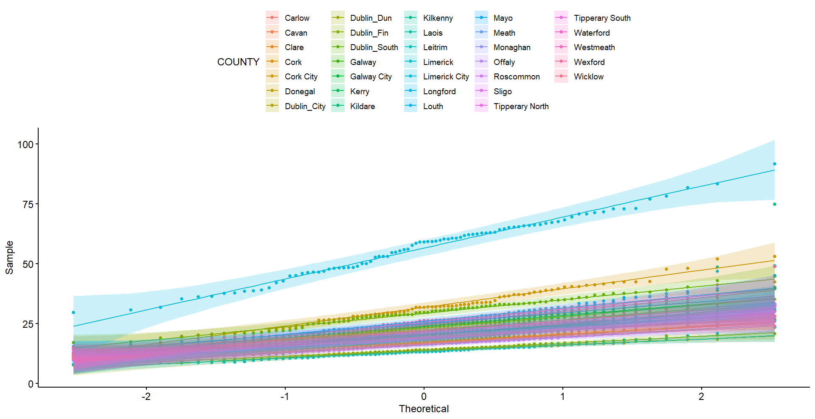

#Using STATA version 16 – running multilevel mixed analysis

///Analysis 2015 to 2022 (by months_county) – total antimicrobial consumption

mixed rate absolutescore male under12 i.covid time i.winter || County: , reml

Performing EM optimization:

Performing gradient-based optimization:

Iteration 0: log restricted-likelihood = -8148.2265

Iteration 1: log restricted-likelihood = -8148.2265

Computing standard errors:

Mixed-effects REML regression Number of obs = 2871

Group variable: County Number of groups = 33

Obs per group: min = 87

avg = 87.0

max = 87

Wald chi2(6) = 1941.41

Log restricted-likelihood = -8148.2265 Prob > chi2 = 0.0000

-------------------------------------------------------------------------------

rate | Coef. Std. Err. z P>|z| [95% Conf. Interval]

--------------+----------------------------------------------------------------

absolutescore | 6.556268 1.378356 4.76 0.000 3.854739 9.257797

male | -.0001301 .0000689 -1.89 0.059 -.0002651 4.87e-06

under12 | .0003784 .0002363 1.60 0.109 -.0000846 .0008415

1.covid | -3.874628 .2689441 -14.41 0.000 -4.401748 -3.347507

time | -.0293779 .0049562 -5.93 0.000 -.0390919 -.019664

1.winter | 4.623908 .1491924 30.99 0.000 4.331496 4.916319

_cons | 37.6651 4.077318 9.24 0.000 29.67371 45.6565

-------------------------------------------------------------------------------

------------------------------------------------------------------------------

Random-effects Parameters | Estimate Std. Err. [95% Conf. Interval]

-----------------------------+------------------------------------------------

County: Identity |

var(_cons) | 31.31113 8.27069 18.65769 52.546

-----------------------------+------------------------------------------------

var(Residual) | 15.90261 .4223834 15.09593 16.75239

------------------------------------------------------------------------------

LR test vs. linear regression: chibar2(01) = 2731.71 Prob >= chibar2 = 0.0000

/*Predict level-1 residuals*/

predict res,res

qnorm res



hist res, normal title("Residuals")

(bin=34, start=-23.569801, width=2.0879941)



predict sresid, rstandard // standardized level 1 residuals

predict predval, xb // predicted outcome value

scatter sresid predval // cloud graph, hopefully no pattern



qnorm sresid // residuals should fall along the line



//The plot reveals increasing variability, which indicates that our within-cluster variance model is misspecified.To relax the assumptions of homoskedasticity or independence of residual errors, use the residuals() option.

///final model

mixed rate absolutescore male under12 i.covid time i.winter || County:,residual(ar 1, t(time)) reml

Obtaining starting values by EM:

Performing gradient-based optimization:

Iteration 0: log restricted-likelihood = -8148.2265

Iteration 1: log restricted-likelihood = -7997.8138

Iteration 2: log restricted-likelihood = -7996.113

Iteration 3: log restricted-likelihood = -7995.9834

Iteration 4: log restricted-likelihood = -7995.9833

Computing standard errors:

Mixed-effects REML regression Number of obs = 2871

Group variable: County Number of groups = 33

Obs per group: min = 87

avg = 87.0

max = 87

Wald chi2(6) = 898.73

Log restricted-likelihood = -7995.9833 Prob > chi2 = 0.0000

-------------------------------------------------------------------------------

rate | Coef. Std. Err. z P>|z| [95% Conf. Interval]

--------------+----------------------------------------------------------------

absolutescore | 6.565631 1.380927 4.75 0.000 3.859063 9.272199

male | -.0001306 .000069 -1.89 0.058 -.0002658 4.67e-06

under12 | .0003802 .0002367 1.61 0.108 -.0000838 .0008441

1.covid | -3.964383 .3708734 -10.69 0.000 -4.691282 -3.237485

time | -.0258288 .0069101 -3.74 0.000 -.0393723 -.0122853

1.winter | 3.560818 .1757892 20.26 0.000 3.216278 3.905359

_cons | 35.77367 5.262078 6.80 0.000 25.46018 46.08715

-------------------------------------------------------------------------------

------------------------------------------------------------------------------

Random-effects Parameters | Estimate Std. Err. [95% Conf. Interval]

-----------------------------+------------------------------------------------

County: Identity |

var(_cons) | 31.22273 8.301582 18.54177 52.57637

-----------------------------+------------------------------------------------

Residual: AR(1) |

rho | .3512446 .0201243 .3111958 .390048

var(e) | 16.44163 .5157592 15.46121 17.48422

------------------------------------------------------------------------------

LR test vs. linear regression: chi2(2) = 3036.19 Prob > chi2 = 0.0000

/// We added the structure of residual errors (autoregressive process of order 1 (AR(1))) to the final multilevel model to improve the model's fit and provide more accurate estimates of the model parameters (the assumptions of homoscedasticity and independence). We only ran a time series analysis of the continuous variable (DID) to verify if the autoregressive (AR) order 1 structure was adequate for the observation structure.

tsset time

time variable: time, 2015m1 to 2022m3

delta: 1 month

corrgram rate, lags (20)

-1 0 1 -1 0 1

LAG AC PAC Q Prob>Q [Autocorrelation] [Partial Autocor]

-------------------------------------------------------------------------------

1 0.6897 0.6918 42.828 0.0000 |----- |-----

2 0.4692 -0.0062 62.88 0.0000 |--- |

3 0.3380 0.0310 73.41 0.0000 |-- |

4 0.1159 -0.2613 74.664 0.0000 | --|

5 -0.0279 -0.0583 74.737 0.0000 | |

6 -0.0342 0.1201 74.849 0.0000 | |

7 -0.0172 0.1022 74.878 0.0000 | |

8 0.0993 0.2501 75.845 0.0000 | |--

9 0.2128 0.1431 80.34 0.0000 |- |-

10 0.2982 0.0882 89.285 0.0000 |-- |

11 0.3762 0.1190 103.71 0.0000 |--- |

12 0.3898 0.0413 119.39 0.0000 |--- |

13 0.2822 -0.1051 127.73 0.0000 |-- |

14 0.1551 -0.0912 130.28 0.0000 |- |

15 -0.0112 -0.1886 130.29 0.0000 | -|

16 -0.1610 -0.1158 133.12 0.0000 -| |

17 -0.2818 -0.2262 141.9 0.0000 --| -|

18 -0.2716 0.0453 150.18 0.0000 --| |

19 -0.1932 0.0386 154.43 0.0000 -| |

20 -0.0467 0.2268 154.68 0.0000 | |-

ac rate



varsoc rate

Selection-order criteria

Sample: 2015m5 - 2022m3 Number of obs = 83

+---------------------------------------------------------------------------+

|lag | LL LR df p FPE AIC HQIC SBIC |

|----+----------------------------------------------------------------------|

| 0 | -231.083 15.7129 5.59236 5.60406 5.6215 |

| 1 | -204.746 52.674 1 0.000 8.53314* 4.98183* 5.00524* 5.04011* |

| 2 | -204.746 .00021 1 0.988 8.74143 5.00592 5.04104 5.09335 |

| 3 | -204.703 .0857 1 0.770 8.94577 5.02898 5.07581 5.14555 |

| 4 | -201.817 5.7719* 1 0.016 8.54895 4.98354 5.04208 5.12925 |

+---------------------------------------------------------------------------+

Endogenous: rate

Exogenous: _cons

///The AIC, HQIC and SBIC information criterion show that the appropriate lag is 1